Northwind-Full 39 Queries

## Exercise 1

Write a SELECT query to display Full name of all employees in lower-case as following:  
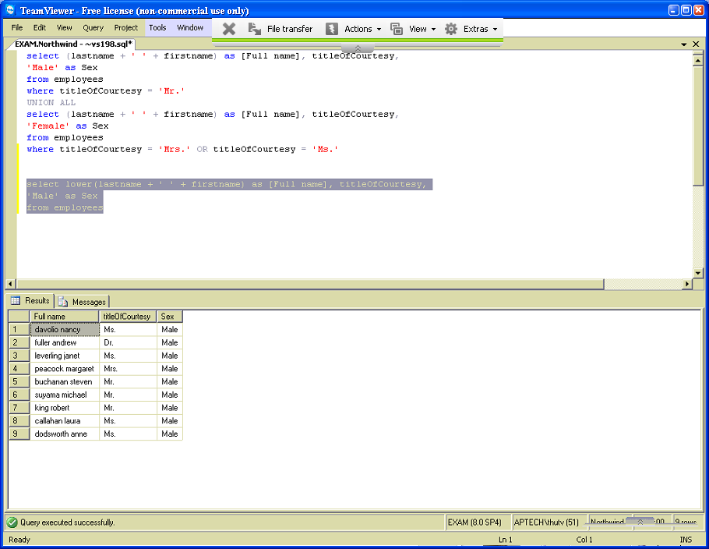

## Exercise 2

Write a SELECT query to display Full name of all employees in upper-case as following:  
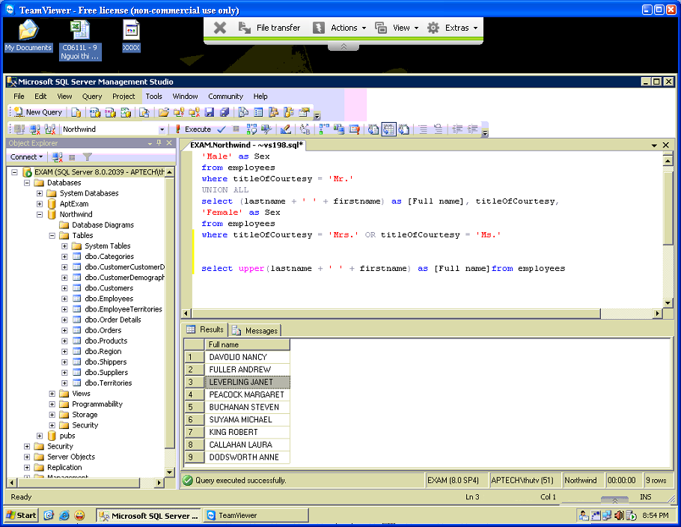

## Exercise 3

Write a SELECT query to display all employees that are from United States as following:  
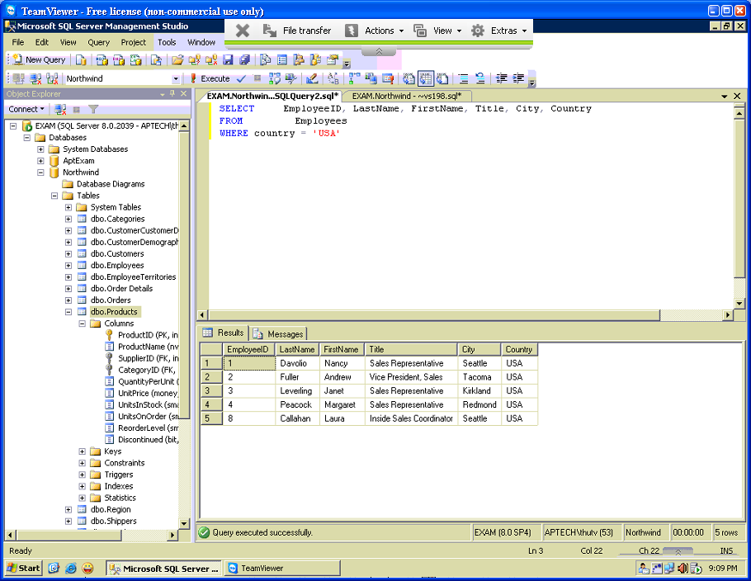

## Exercise 4

Write a SELECT query to display all customers that are from UK as following:  
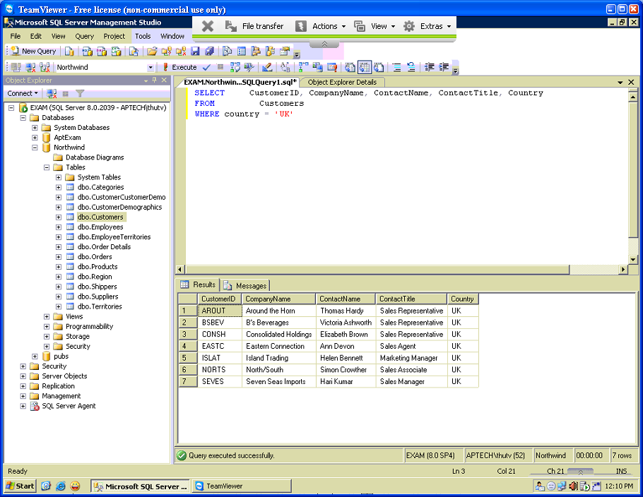

## Exercise 5

Write a SELECT query to display all customers that are from Mexico as following:  
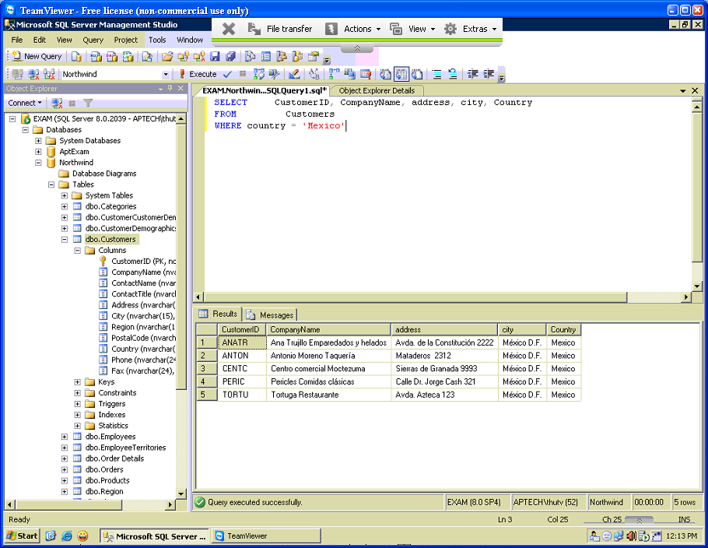

## Exercise 6

Write a SELECT query to display all customers that are from Sweden as following:  
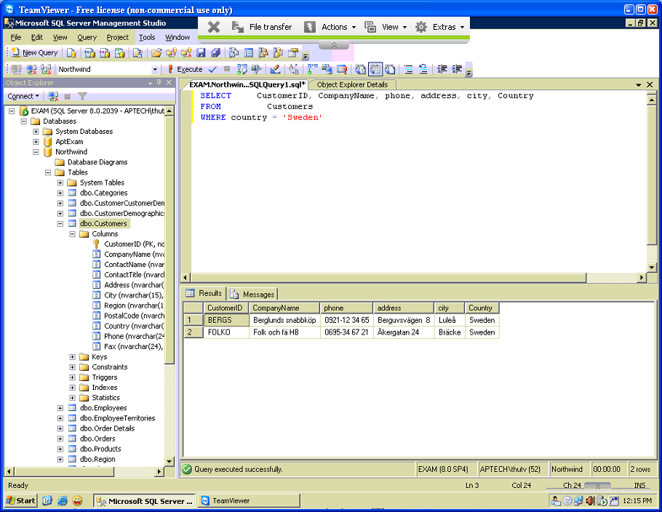

## Exercise 7

In Products table, values of UnitsInStock tell you the total units in the inventory of every product. Write a SELECT query to display product id, product name, unit price of all products such that their total units in the inventory is between 5 and 10 as following:  
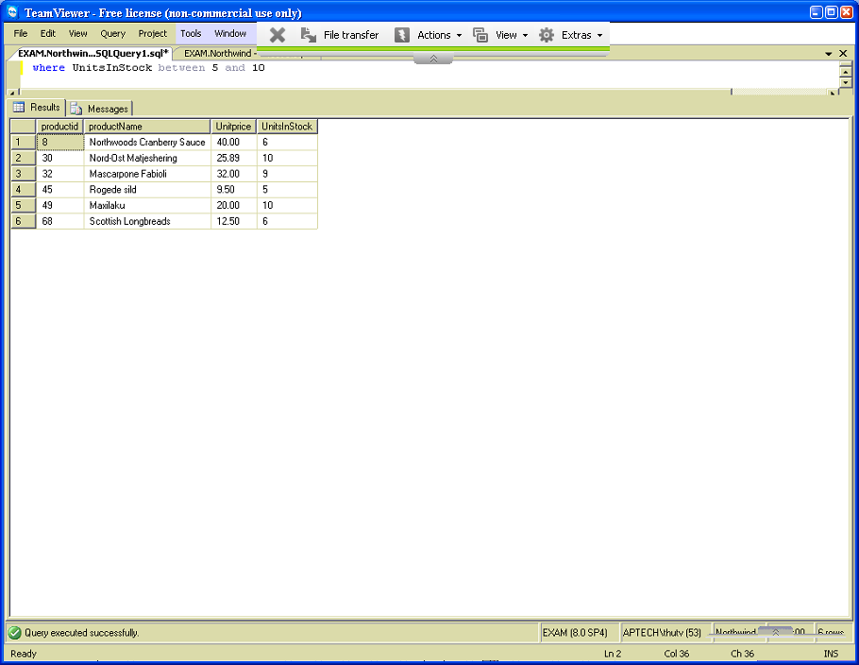

## Exercise 8

In Products table, the value of UnitsOnOrder tells you the total ordered units for every product. Write a SELECT query to display product id, product name, unit price, re-order level… of all products that have total ordered units between 60 and 100 as following:  
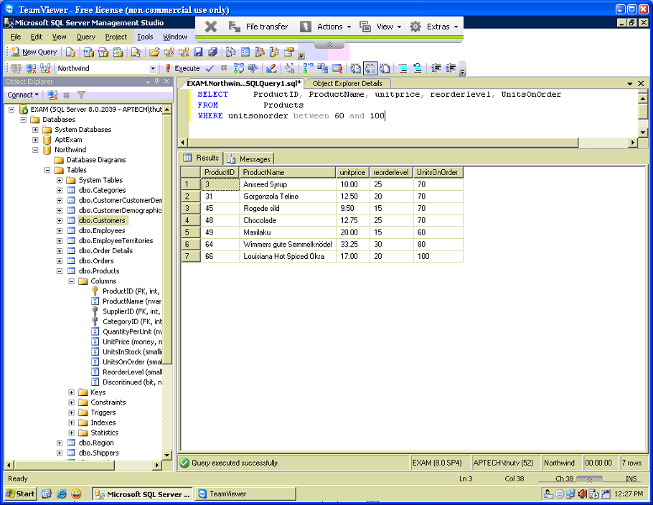

## Exercise 9

Write a SELECT query to display total orders of every employee in 1996 as following:  
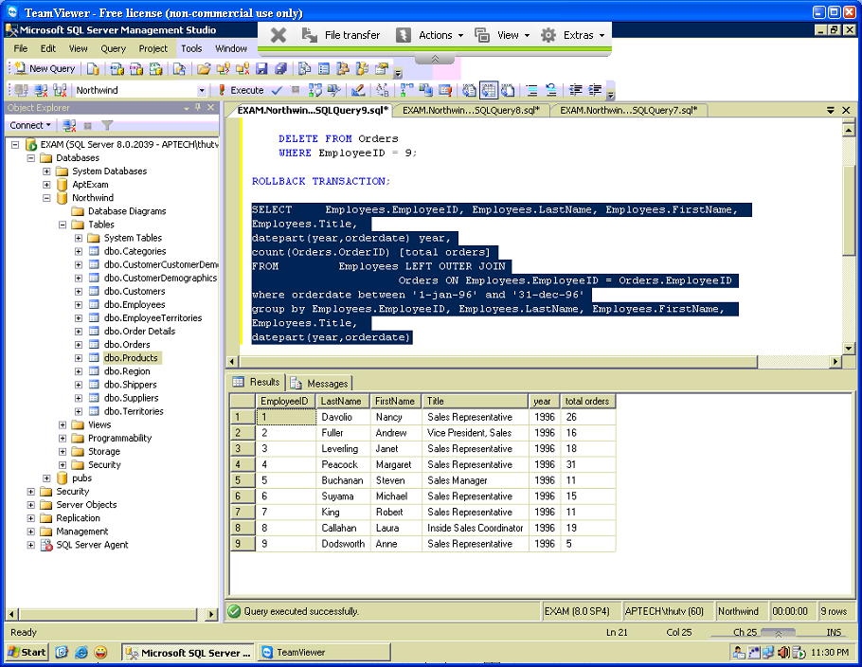

## Exercise 10

Write a SELECT query to display total orders of every employee in 1998 as following:  
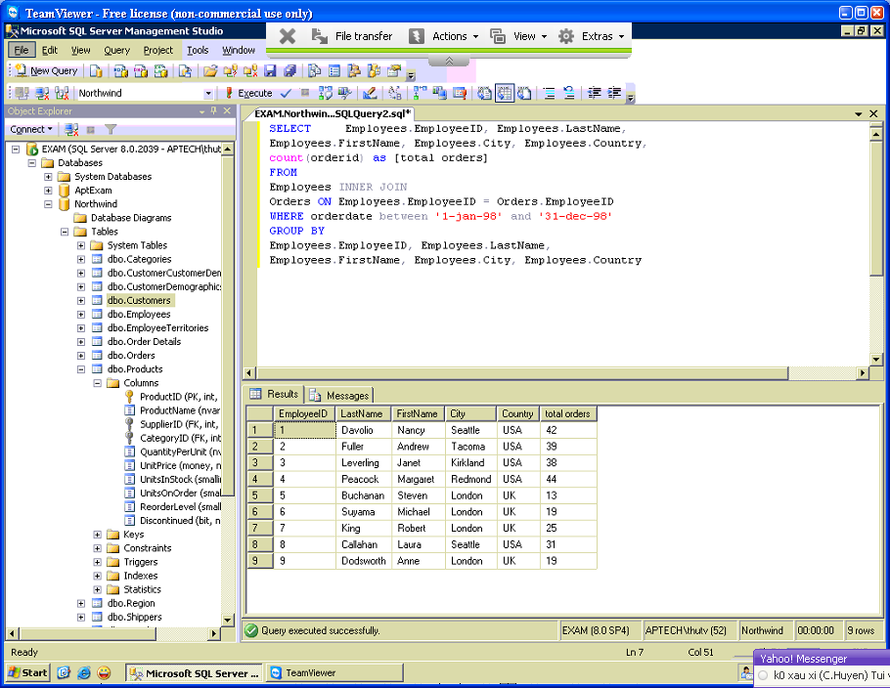

## Exercise 11

Write a SELECT query to display total orders of every employee from 1/1/1998 to 31/7/1998 - orderDate as following:  
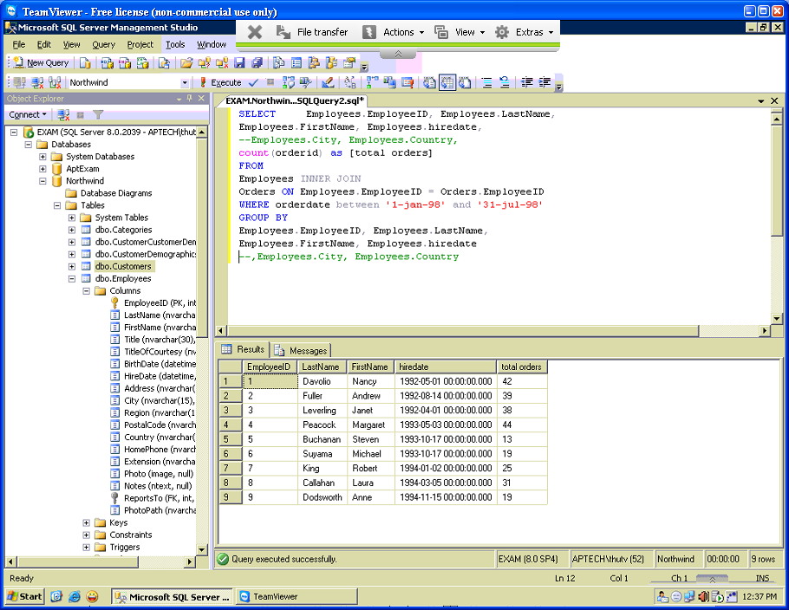

## Exercise 12

Write a SELECT query to display total orders of every employee from 1/1/1997 to 30/6/1997 as following:  
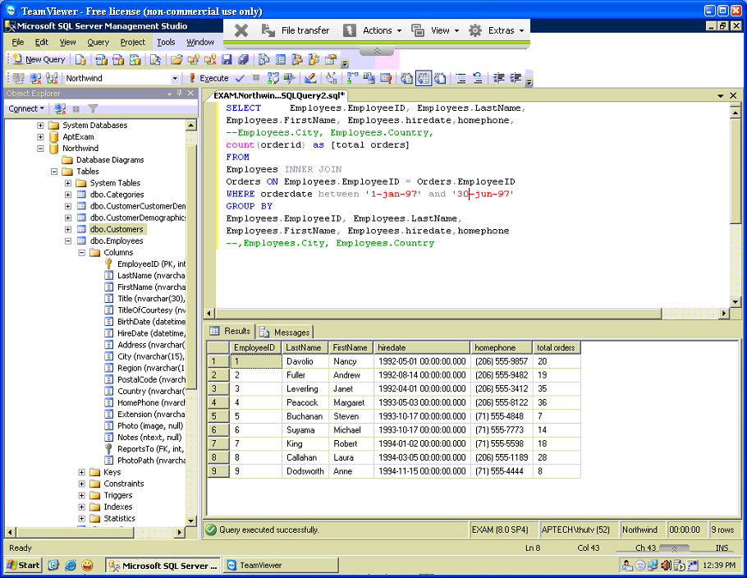

## Exercise 13

An order will be taxed 10% if its freight cost is larger than or equal to 100$.

Otherwise, an order will be taxed 5% if its freight cost is smaller than 100$.

Write a SELECT query to show the freight with taxes of orders placed between 1/8/1996 and 5/8/1996 as following:

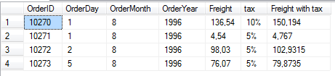

## Exercise 14

Write a SELECT query to display the full name, title of courtesy and sex for all employees such that: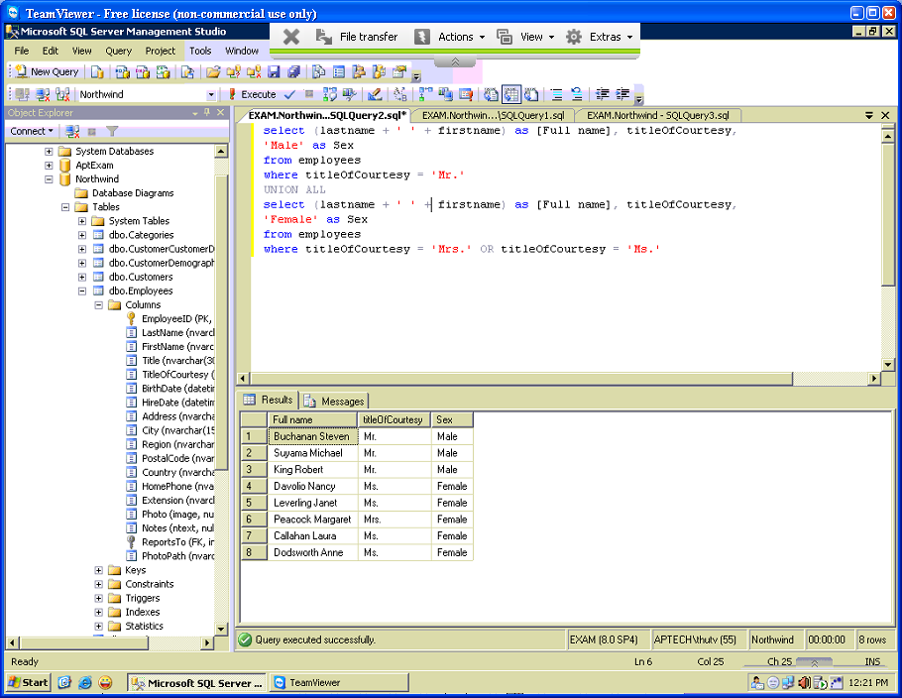

* If title of courtesy is ‘Mr.’ then sex is set to ‘Male’
* If title of courtesy is ‘Ms.’ or ‘Mrs.’ then sex is set to ‘Female’

## 

## Exercise 15

Write a SELECT query to display the full name, title of courtesy and sex for all employees such that: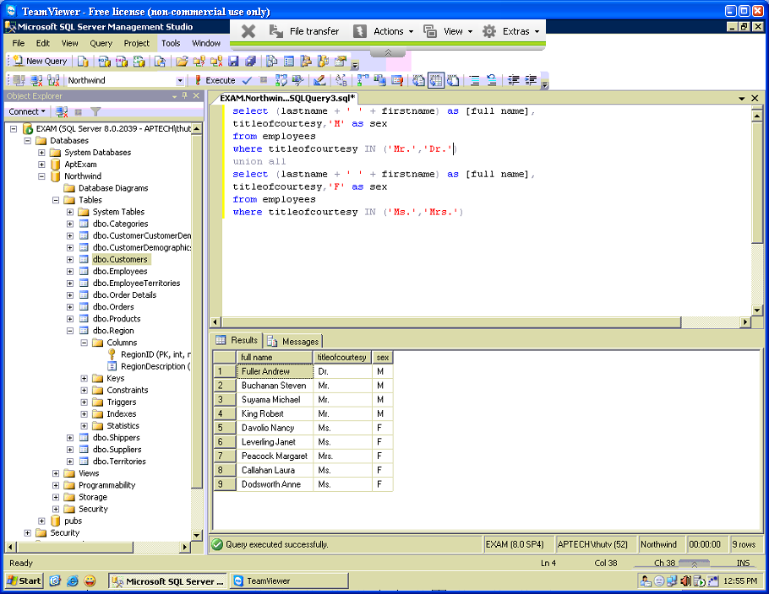

* If title of courtesy is ‘Mr.’ or ‘Dr.’ then sex is set to ‘M’
* If title of courtesy is ‘Ms.’ or ‘Mrs.’ then sex is set to ‘F’

## Exercise 16

Write a SELECT query to display the full name, title of courtesy and sex for all employees such that:

* If title of courtesy is ‘Mr.’ then sex is set to ‘Male’
* If title of courtesy is ‘Ms.’ or ‘Mrs.’ then sex is set to ‘Female’
* If title of courtesy is not ‘Mr.’ and not ‘Mrs.’ and not ‘Ms.’ then sex is set to ‘Unknown’

## Exercise 17

Write a SELECT query to display the full name, title of courtesy and sex for all employees such that:

* If title of courtesy is ‘Mr.’ then sex is set to 1
* If title of courtesy is ‘Ms.’ or ‘Mrs.’ then sex is set to 0
* If title of courtesy is not ‘Mr.’ and not ‘Mrs.’ and not ‘Ms.’ then sex is set to 2

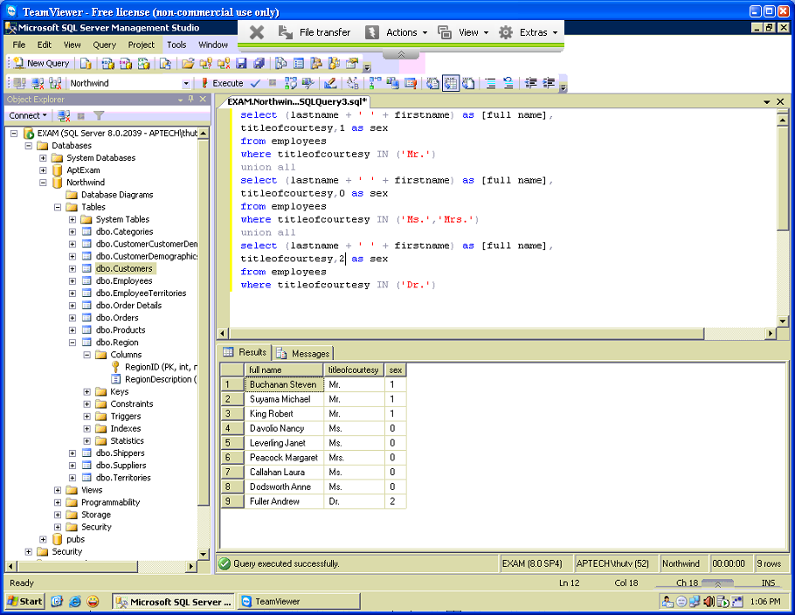

## Exercise 21

Write a query to determine the revenues for all products from 1/7/1996 to 5/7/1996 as following (Revenue = Quantity * Unitprice). **Note**: The output must be order by category id and then product id.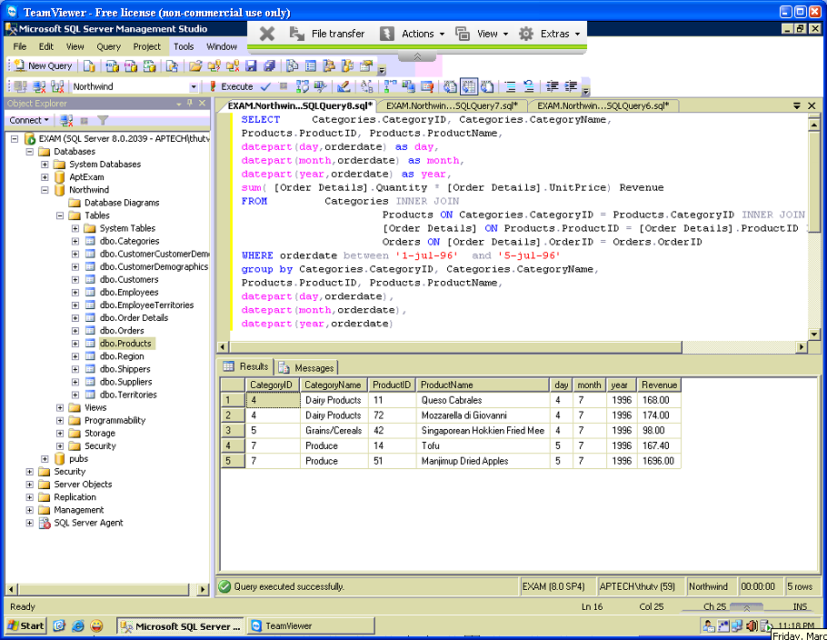

## 

## Exercise 23

Write a query to display the names and telephone numbers of all employees and all customers satisfy the condition: all customers have names start with ‘W’.

## Exercise 24

Write a query to display information about the customer that placed the order with Id equal to 10643 as following:  
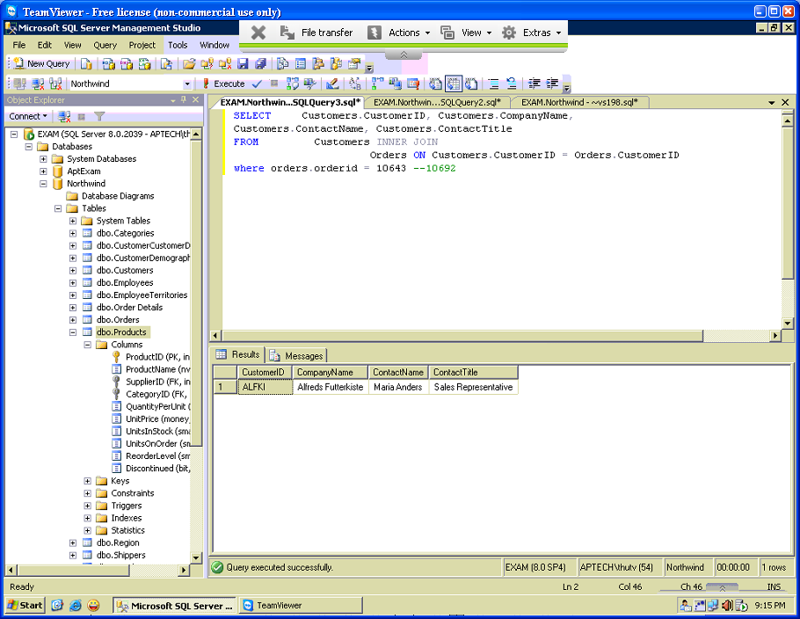

## Exercise 25

Write a query to display the product ids, product names and total units ordered of all products that satisfy: the total units ordered must be greater than or equal to 1200 units.

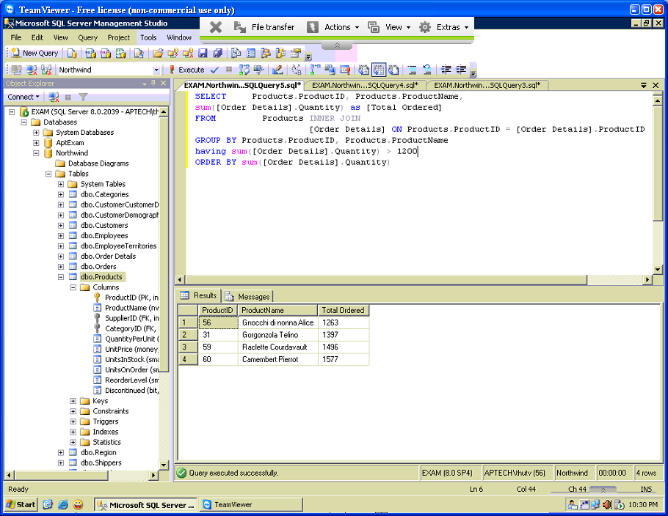

## Exercise 26

Write a query to display the product ids, product names, supplier id, category id and total units ordered of all products that satisfy: the total units ordered must be greater than or equal to 1400 units.  
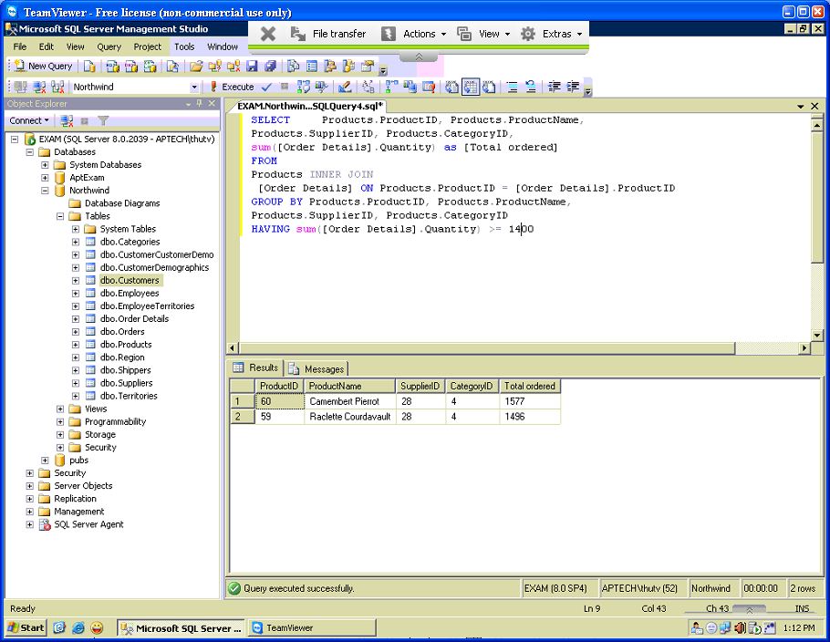

## Exercise 27

Write a query to display the categories that have maximum total product as following:

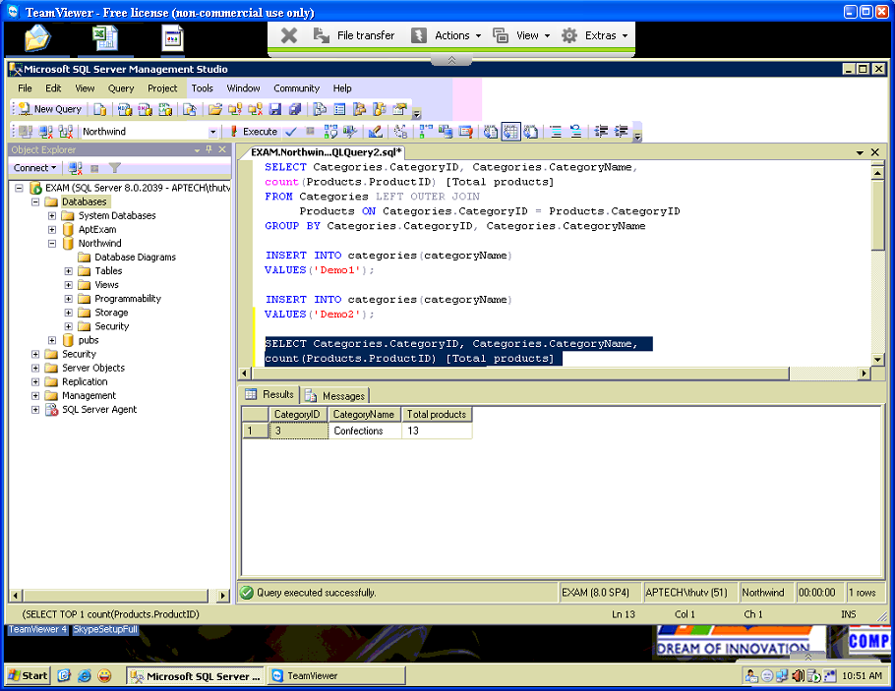

## Exercise 28

Write a query to display the categories that have minimum total product as following:

## Exercise 29

Write a query to display the total record in Customer and Employees tables:  
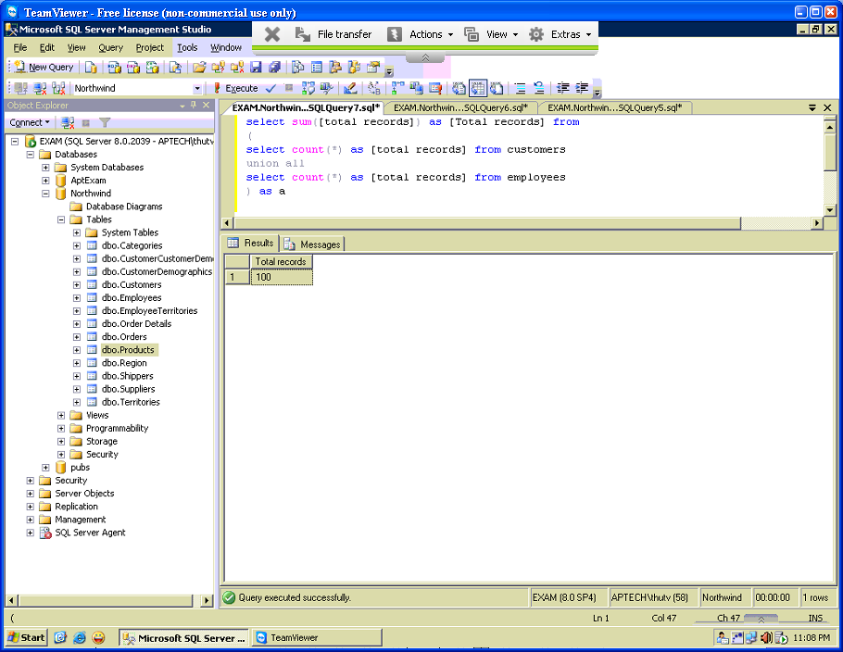

## Exercise 31

Write a query to display information about employees who have maximum total orders as following:  
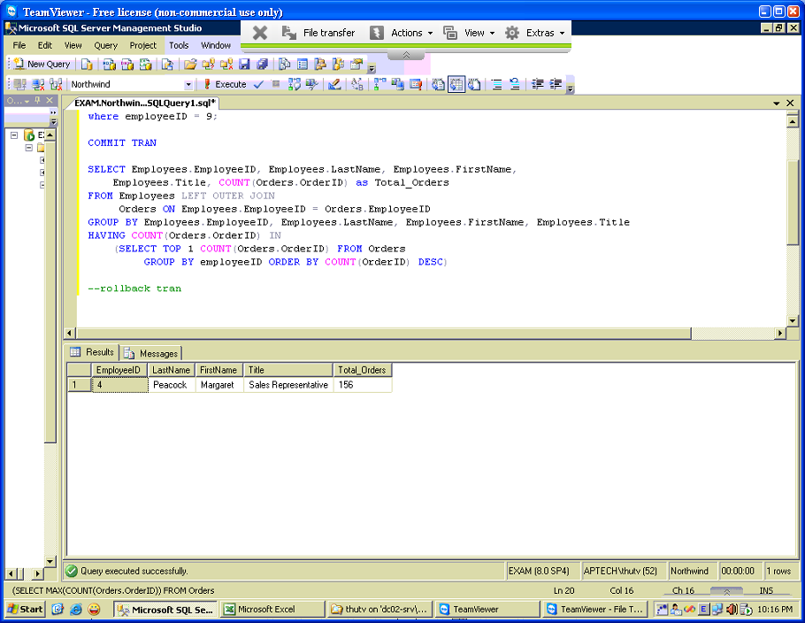

## Exercise 32

In Products table, the value of UnitsInStock tells you the total unit in the inventory for every product. Write a query to display information about products that have maximum total unit in inventory as following: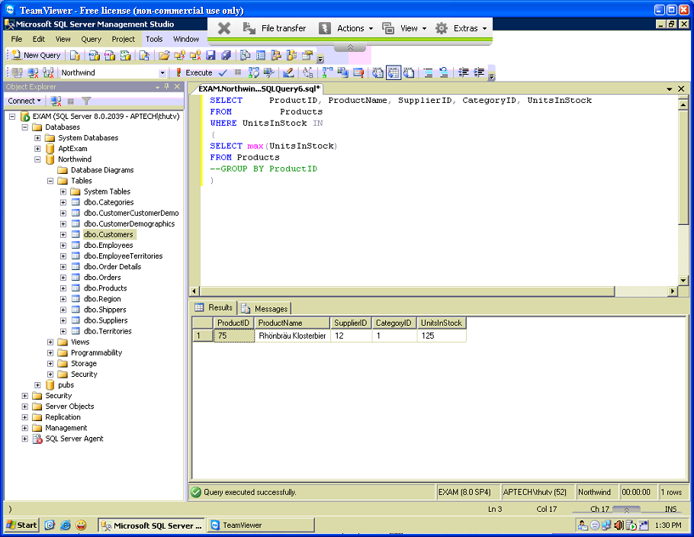

## 

## Exercise 33

In Products table, the value of UnitsInStock tells you the total unit in the inventory for every product. Write a query to display information about products that have minimum total unit in inventory as following: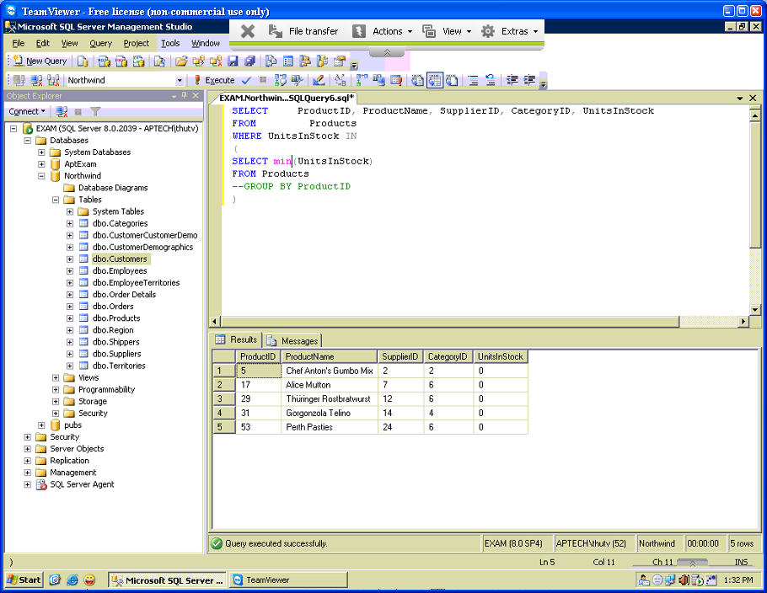

## Exercise 34

In Products table, the value of UnitsOnOrder tells you the total ordered unit for every product. Write a query to display information about products that have maximum total ordered unit as following:

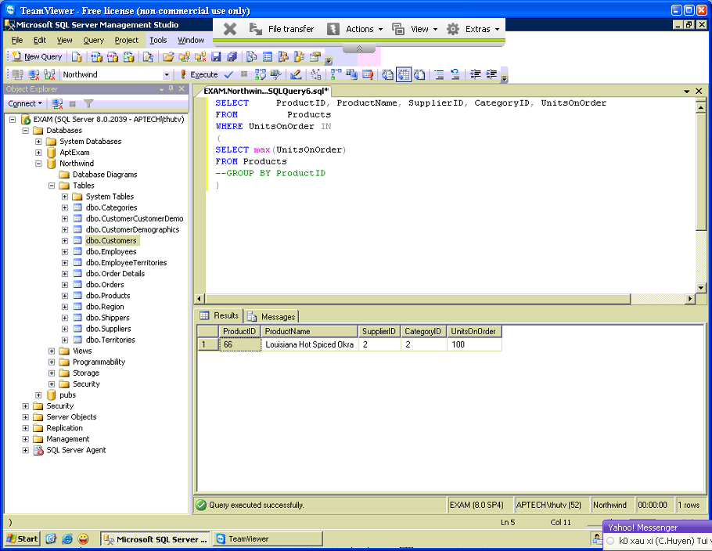

## Exercise 35

In Products table, the value of ReOrderLevel tells you the re-order level for every product. Write a query to display information about products that have maximum re-order level as following:

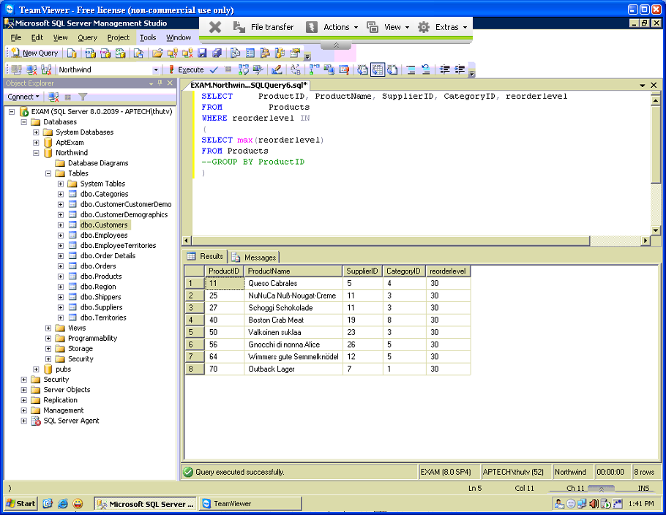

## 

## Exercise 36

Write a query to display the information about employees who have maximum total delayed-orders as following:

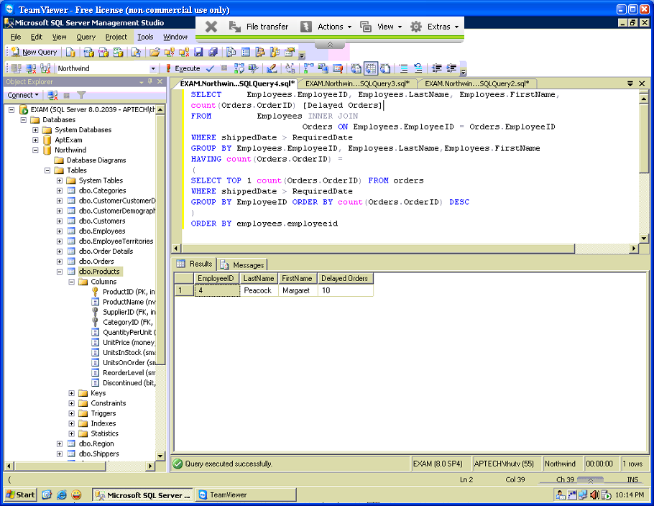

## Exercise 37

Write a query to display the information about employees who have at least one delayed-order and have minimum total delayed-orders as following:  
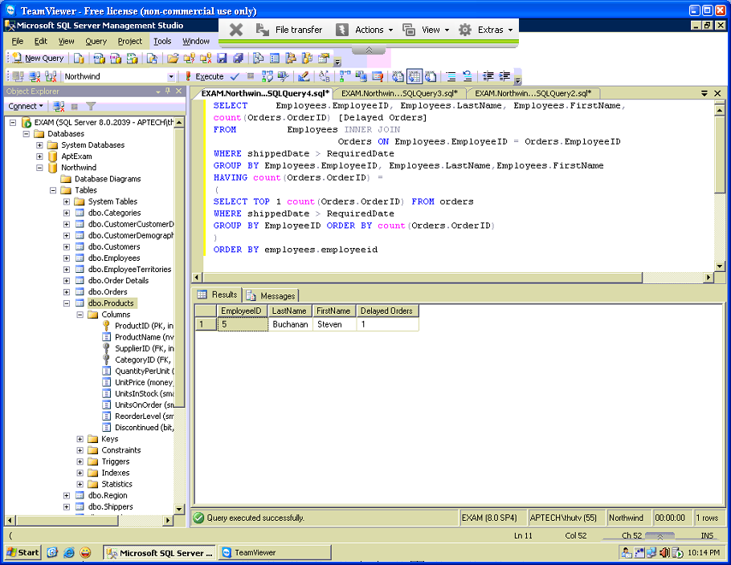

## Exercise 38

Write a query to display product ids and product names of all products that have total ordered-units in three-highest level (top 3 to top 1) as following:

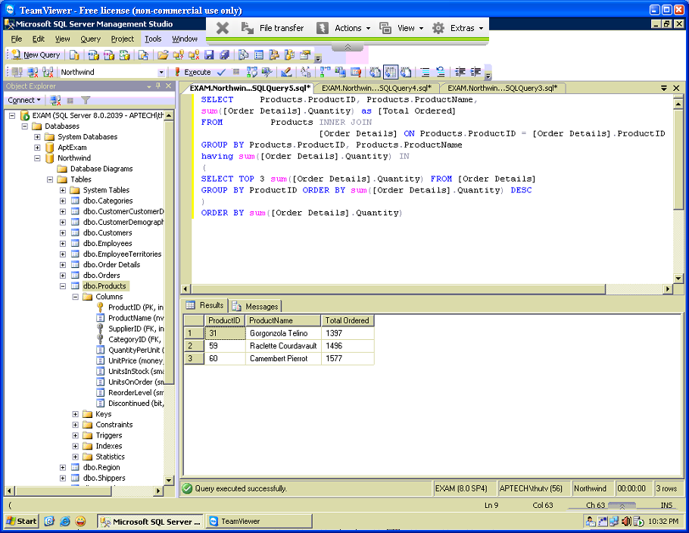

## Exercise 39

Write a query to display product ids and product names of all products that have total ordered-units in five-highest level (top 5 to top 1) as following:  
